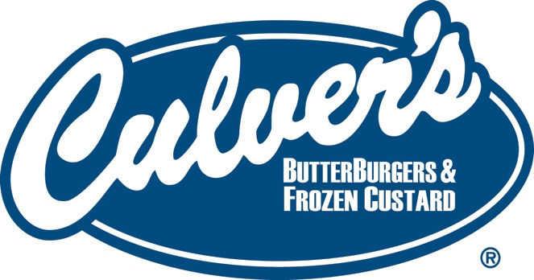

Participating Chicagoland Culver’s Locations

ARLINGTON HEIGHTS 2060 Northwest Highway Arlington Heights, IL 60004
AURORA 509 State Road 59 Aurora, IL 60504
BERWYN 6943 W. Roosevelt Road Berwyn, IL 60402
BOLINGBROOK 250 N. Bolingbrook Drive Bolingbrook, IL 60440
BRIDGEVIEW 9229 S. Harlem Avenue Bridgeview, IL 60455
CHICAGO 3355 S. Martin Luther King Drive Chicago, IL 60616
CHICAGO 4939 W. Irving Park Road Chicago, IL 60453
CRYSTAL LAKE 400 Pingree Road Crystal Lake, IL 60014
DARIEN 531 Plainfield Road Darien, IL 60561
ELMWOOD PARK 7542 W. Grand Avenue Elmwood Park, IL 60707
EVERGREEN PARK 9515 S. Kedzie Avenue Evergreen Park, IL 60805
FRANKLIN PARK 2751 Rose Street Franklin Park, IL 60131
HOMEWOOD 850 W. 183rd Street Homewood, IL 60430
JOLIET 219 S. Larkin Avenue Joliet, IL 60436
LOCKPORT 15940 S. Farrell Road Lockport, IL 60441
LYONS 8211 Ogden Avenue Lyons, IL 60534
MATTESON 20716 S. Cicero Avenue Matteson, IL 60443
MOUNT PROSPECT 1501 Dempster Street Mount Prospect, IL 60056
NEW LENOX 421 E. Lincoln Highway New Lenox, IL 60451
OAK LAWN 10745 S. Cicero Avenue Oak Lawn, IL 60453
ORLAND PARK 9130 W. 159th Street Orland Park, IL 60462
ROSEMONT 7050 Mannheim Road Rosemont, IL 60018
SCHAUMBURG 1800 Wise Road Schaumburg, IL 60193
ST. CHARLES 111 S. Randall Road St. Charles, IL 60174
TINLEY PARK 18248 Sayre Avenue Tinley Park, IL 60477

